***LAB ASSIGNMENT 1 (ECSE373L)***

**TASK 1**

*UPDATE PUTTY (LINUX) –*

* sudo yum update

*SERVER STATUS –*

* sudo service httpd status

*APACHE SERVER START STOP (LINUX) –*

* sudo systemctl start httpd
* sudo systemctl stop httpd

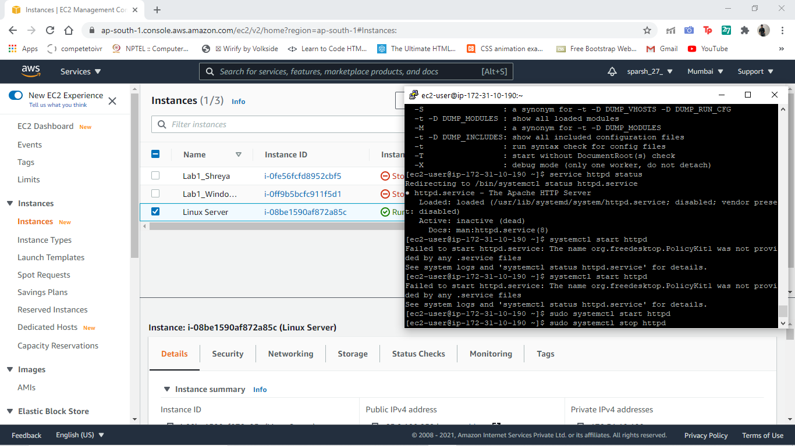

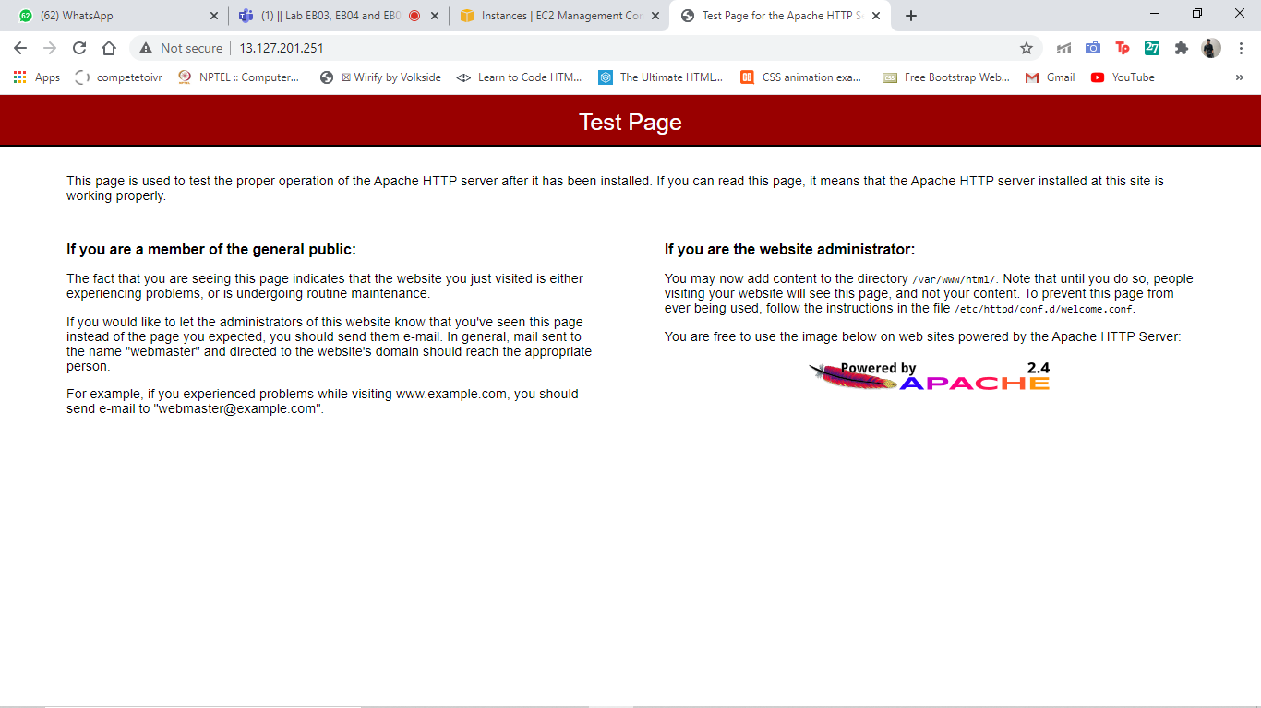

**TASK 2**

**USER 1:**

(This user has rights only to access the S3 storage buckets. No EC2 instances would be visible/able to create to this user)

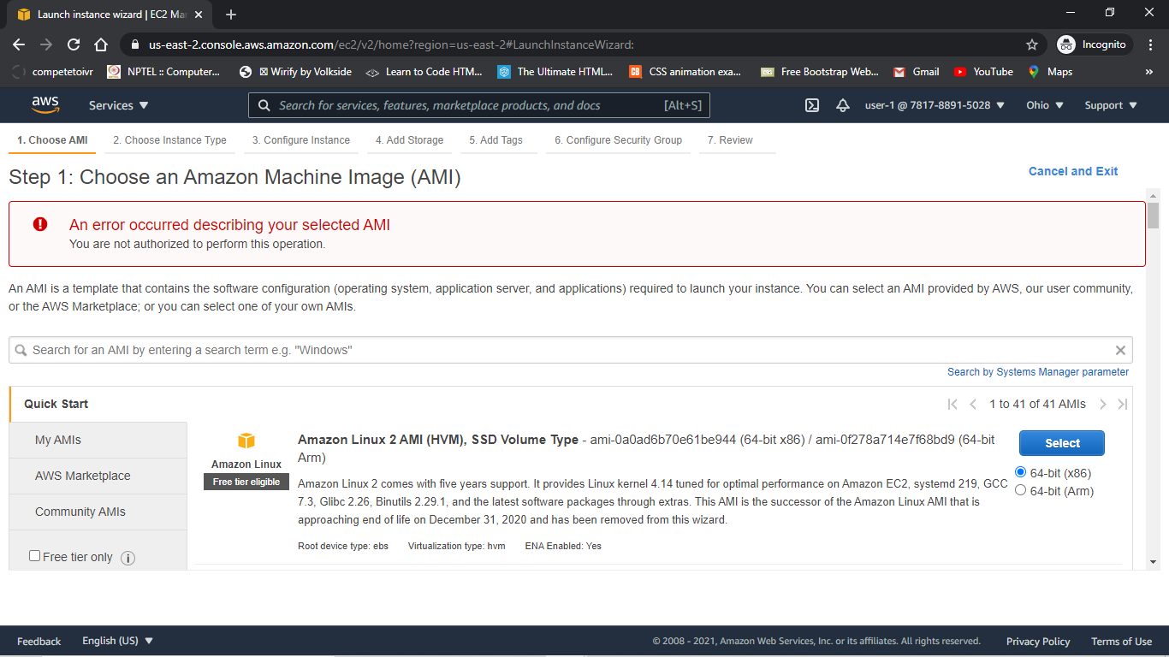

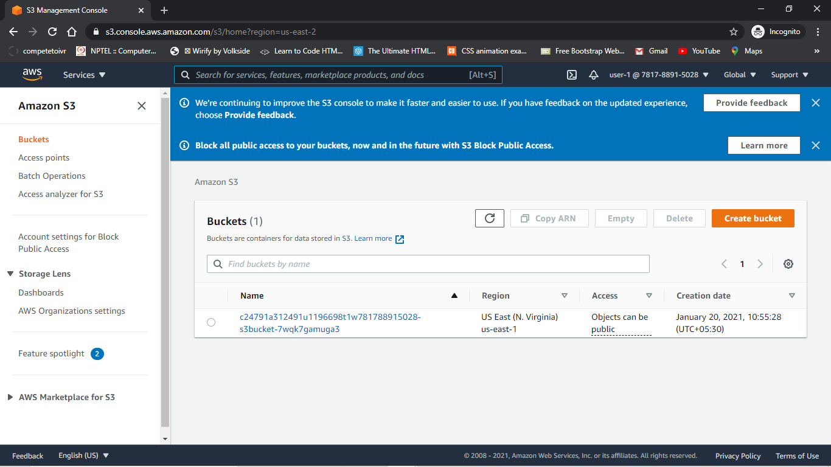

**USER 2:**

(Have Permissions to view EC2 instances but is not able to modify the insatnces)

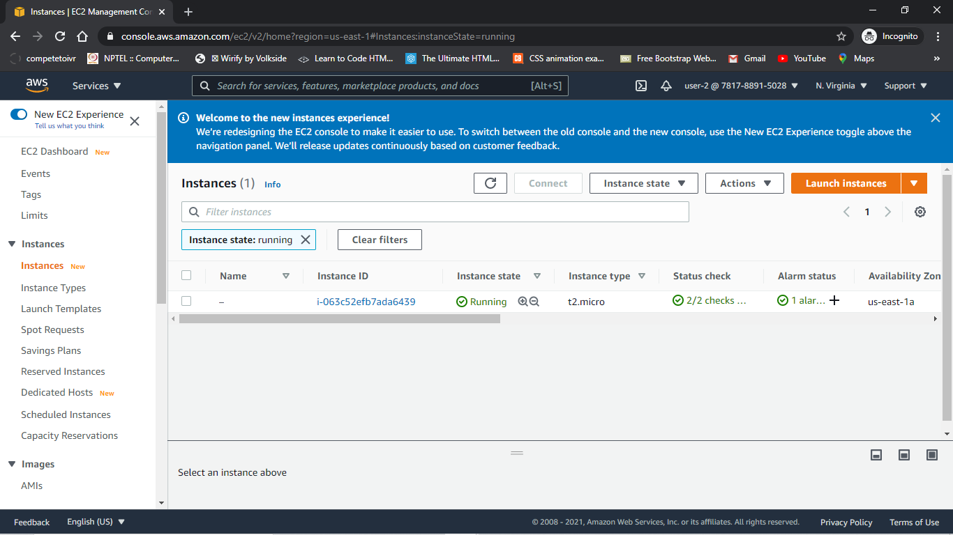

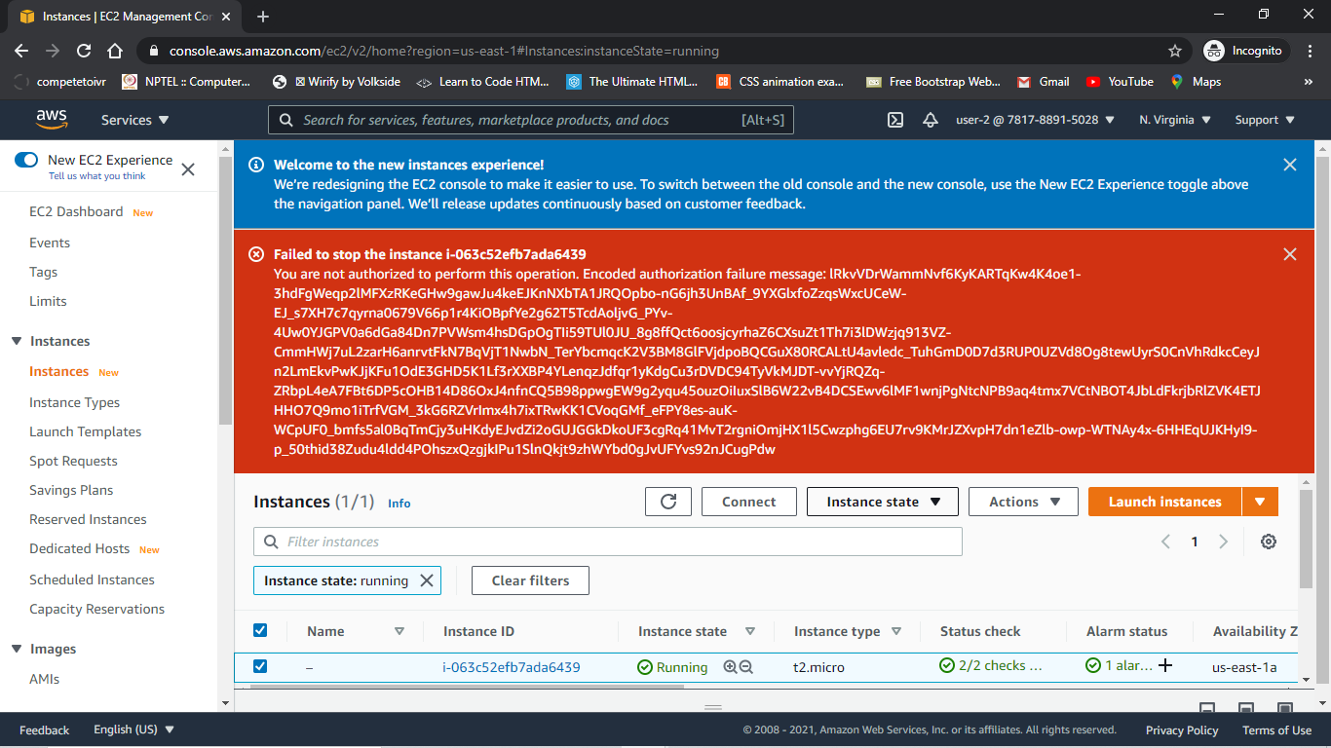

**USER 3 :**

(System Admnistrator that has full rights to modify view and edit the EC2 instances)

